Thick-Film ZnO Semiconducting Structures via Direct Ink Write Printing
Rayne Wolf
University of Wisconsin – Madison, Department of Industrial & Systems Engineering,
Madison, WI, United States of America
NASA Marshall Space Flight Center
EM-42 Advanced Manufacturing Branch
Abstract
To support future human presence on the Moon and Mars it is essential for astronauts to have the capability to manufacture electronic devices in space. The first step in realizing this goal is to develop semiconducting materials that are capable of being used in a flexible manufacturing process. ZnO is explored for its ability to be used as an ink for Direct Ink Write (DIW) printing and for its functionality as a semiconducting layer in a resistive random-access memory (RRAM) device. The sintering conditions required for functionality are explored and a switching RRAM device is fabricated using a commercial silver ink and the optimal sintering conditions. The functional device requires a low sintering temperature for a long period of time using a low ramp rate to avoid microcracking between the silver electrodes. Finally, switching behavior is exhibited with a forming voltage of 3.2V (V_{form}), a set voltage of 2.75V (V_{set}), and a reset voltage of 2.25V (V_{reset}) showing promising RRAM capabilities.
- Introduction
National Aeronautics and Space Administration (NASA) On Demand Manufacturing of Electronics (ODME) overall project goal is to develop and demonstrate the feasibility of a low-gravity, on-demand manufacturing system for semiconductor electronic devices on the international space station (ISS) and commercial low earth orbit destinations. It is essential for astronauts to have the ability to readily and easily replace faulty electronic devices using a small compact manufacturing process. Flexible methods of electronic manufacturing of semiconductors are still being developed by NASA on earth. Thin and thick film electronics have been successfully manufactured using Direct Ink Write (DIW) additive manufacturing and it provides a promising solution to achieve low-gravity printing. ZnO has good semiconducting characteristics while being low-cost and environmentally friendly. Demonstrating ZnO ‘switching’ ability would show its potential to be used in resistive random-access memory (RRAM) devices.
- Background
DIW is an extrusion-based additive manufacturing method in which viscous ink is dispersed from a nozzle using a controlled flow rate. The ink is extruded using pneumatic pressure through a nozzle with a short stand-off distance to the substrate. First, a meniscus is formed at the tip of the nozzle as pressure is applied, and wetting occurs between the ink and substrate (Y. Park et al., 2022). When sufficient wetting is achieved, the ink is drawn onto the substrate via a moving nozzle onto the xy-plane. It is capable of high resolution single or multi-layer patterning; commercially available DIW printers can achieve printed line widths of as small as 30 µm (Y. Park et al., 2022).

DIW has been studied for a variety of electronic applications including electrodes, electronic circuits for energy conversion and storage, and functional components like transistors, sensors, antennas, and light emitting diodes (A. Janotti and C. G. Van de Walle, 2009). A variety of semiconductive structures have been patterned using DIW. Quantum dot-based light-emitting diodes were DIW printed using inorganic nanoparticles CdSe/ZeS (Y. L. Kong et al., 2014). Low power acetone gas sensors were printed using copper and iron with ethanol and PVB, then thermal annealed to create CuO/Cu₂O/Cu and Fe₂O₃/Fe respectively (L. Siebert et al., 2020). Arango et al. discovered that DIW printing parameters, ink formulations, device size, and sintering conditions can affect the crystallographic-growth, materials’ microstructure, and overall morphology of Al-doped ZnO inks post-cure (M. A. Torres Arango, O. A. Abidakun, D. Korakakis, and K. A. Sierros, 2017). However, there has been relatively little work done to characterize DIW printed Resistive Random Access Memory (RRAM) devices.

A memristor is an electrical device that controls the amount of electrical current within a circuit and remembers the amount of charge that has previously flowed through it. It is non-volatile meaning it can retain this memory without power. RRAM is a type of non-volatile memristor technology that utilizes resistive switching to store and retrieve data. It typically consists of a thin solid-state insulator (I) sandwiched between two metal (M) electrodes, otherwise known as a MIM structure. The insulator layer, usually a metal oxide, exhibit resistive switching, which allows them to change their resistance state in response to an applied electric field. When an external voltage pulse is applied the RRAM devices prompts a transition from a high resistance state (HRS), or also known as the ‘OFF’ (logic value ‘0’), to a low resistance state (LRS), or ‘ON’ (logic value ‘1’)( F. Zahoor, T. Z. Azni Zulkifli, and F. A. Khanday, 2020). This switching behavior determines the change of resistance values within the RRAM device. When switching the device from the HRS to the LRS, a high pulse voltage, defined as the ‘forming voltage’, is applied which enables conductive paths to form within the switching layer. These conductive paths enable the LRS. To switch back from the LRS to the HRS, the voltage pulse, defined as the ‘reset voltage’, is applied to unable the conductive paths. The voltage as which the switching behavior directly occurs is defined as the ‘set voltage’. A higher voltage allows data to be written into the RRAM cell, while a lower voltage allows data to be read and retrieved. There are two different ways that these conductive paths can form. The first is metal-ion based switching in which an electron bridge is formed within the metal oxide layer by subsequent redox reactions as seen in Figure 1a. The oxidation at the top electrodes lead to the migration of metal cations toward the cathode where they are reduced. When a positive voltage is applied the buildup of these metal atoms form an electron bridge, and this switched the device into the “on” state. When the voltage is reversed, dissolution takes place of the electron bridge, putting the device into the “off” state. The second way a conductive bridge can form is through oxygen vacancies as seen in Figure 1b. Within the forming process, there is a soft breakdown of the metal oxide resulting in an oxide layer between the dielectric and top electrode. Upon the application of an electric field the oxygen atoms are knocked out of there lattice and become oxygen ions at the anode interface, this leave oxygen vacancies, which allow the metal oxide to become more conductive by allowing electrons to move through these vacancies through the device. This is the device in its “ON” state. To put the device in its “OFF” state, the voltage is reversed, and the oxygen ions migrate back towards the metal oxide thus prohibiting the free movement of electrons. The behavior of this switching behavior can be illustrated in the I-V curve in Figure 2. The device starts in a HRS then a forming voltage (V_{form}) is used to create a conductive bridge within the device. Once created, the device switches to a LRS or “ON”, when the voltage is reversed the device switches back to a HRS or “OFF” once the reset voltage (V_{reset}) is reached. Again, once the reverse voltage is applied and the set voltage (V_{set}) threshold is reached, the device is switched back to a LRS and the cycle continues. RRAM devices have several desirable characteristics, including high on/off current ratios, ultra-low switching voltage, robust cycling stability, and a long retention time (S. Xu and W. Wu, 2020). Other memory devices, such as DRAM, flash, and static cells have gotten as small as they can get, hence the demand for developing devices able of storing bits as resistance.
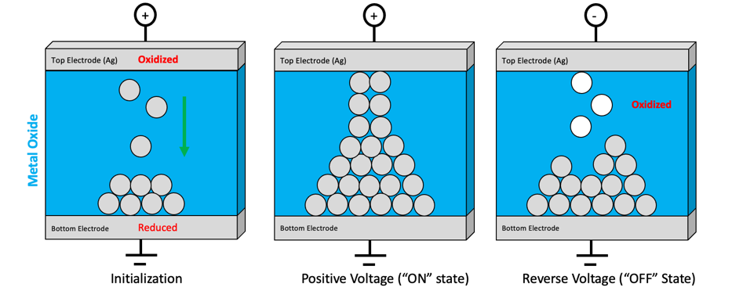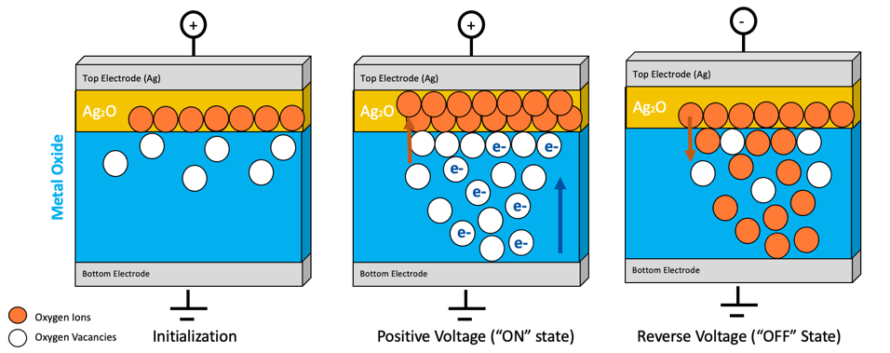
a)
b)
Figure 1: a) Metal-ion based switching and b) Oxygen vacancy based switching from initialization to the application of positive (forward) voltage to switch the RRAM device to the “ON” state then switching to the “OFF” state via the application of reverse voltage.

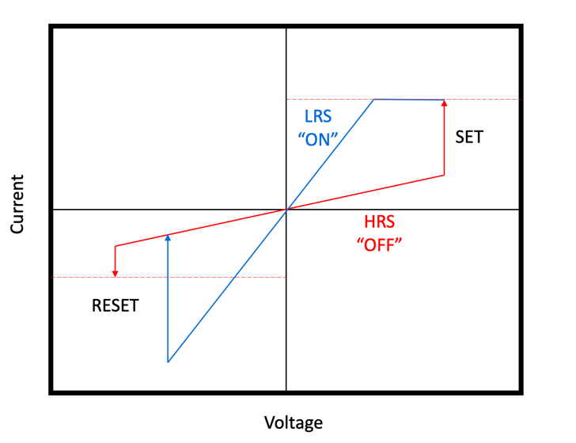
Figure 2: I-V curve of a RRAM device.

The additive manufacturing of RRAM components has been studied using ink-jet printing, screen-printing, drop-on-demand printing, aerosol jet printing, screen printing, and electrohydrodynamic printing. A summary of the previous methods, materials, and performance can be found in Table X. To our knowledge, DIW printed RRAM devices have not been studied and is the purpose of this work.

Many metal oxides have been studied for their effectiveness as the insulating/semiconducting layer in the MIM structure and have exhibited non-volatile resisting switching within RRAM devices. ZnO has advantageous properties such as being chemically stable, electrochemical active, controllable electrical behavior, and a wide, direct band gap of 3.4 eV (F. M. Simanjuntak, D. Panda, K.-H. Wei, and T.-Y. Tseng, 2016). ZnO inks have been formulated for a number of additive manufacturing techniques including screen printing, gravure printing, flexographic printing, 3D printing, inkjet printing, and dip pen nanolithography (G. Arrabito et al., 2020). Much of the previous work has been done on liquid, low-viscosity inks for these applications. One study has shown promising results for high-viscosity, nanoparticle-based inks capable of DIW printing. Tubìo et al. investigated several solid loadings of ZnO in ink formulation (44-52 vol%) for extrusion-based printing of self-supporting structures and obtained rod diameters of 200µm (C. R. Tubío, F. Guitián, and A. Gil, 2016). However, the electrical behavior was not studied, thus, another purpose of this work is to formulate a ZnO ink capable of DIW while maintaining sufficient switching behavior for RRAM devices.

Type of Printing | Printed Structures | Electrode Material | Semiconductor Material | Thickness | Substrate | Heat Treatment Temperature (℃) | Low Resistance State | High Resistance State | Source
Inkjet | Semiconductor layer | Bottom: Ag  Top: Ti | TiO_{x} | 70-80 nm (Semiconductor) | Glass | None, 250, 300, 350, 400, 450 (semiconductor) | 40Ω, 30Ω, 80Ω, 250Ω, 50Ω, 20000 Ω | 200Ω, 140Ω, 2300Ω, 5600Ω, 14500Ω, 100000 Ω | M. Nelo et al., 2013
Inkjet | Semiconductor layer | Bottom: Ag  Top: Cu | TiO_{x} | 70-80 nm (Semiconductor) | Glass | None, 250, 300, 350, 450 (semiconductor) | 6Ω, 4Ω, 13Ω, 12Ω, 35Ω | 16Ω, 20Ω, 35Ω, 38Ω, 550Ω | M. Nelo et al., 2013
Inkjet, screen | Bottom and top electrode | Ag nanoparticle | MoO_{x}/MoS₂ | 50-100 nm (Semiconductor) | PEN | 200 (electrodes) | 150M Ω | 30 Ω | A. A. Bessonov et al., 2014
Aerosol Jet | Semiconductor layer, bottom and top electrode | Bottom: Au  Top: Cu | Polymer/Cu-SiO₂ NW composite | 450 nm (Bottom), 4.5µm (Semiconductor), 900 nm (Top) | Glass | 280 (bottom), 160 (top) | 5500 Ω | 100000000 Ω | M. J. Catenacci et al., 2017
Screen | Semiconductor layer, top electrode | Bottom: Platinum Top: Carbon | ZnO+EC | 10 µm (Semiconductor) | Paper | 120 (semiconductor) | ~10000 Ω | ~1000000 Ω | M. A. M. Franco, 2016
Screen | Semiconductor, top electrode | Bottom: Platinum Top: Ag | ZnO+EC | 10 µm (Semiconductor) | Paper | 120 (semiconductor) | ~100000 Ω | ~55000000 Ω | M. A. M. Franco, 2016
EHD (Drop-on-demand for electrodes. Electrostatic spray deposition for semiconductor) | Electrodes | Ag | Poly(4-vinylphenol) (PVP) | 300 nm (Electrodes), 120 nm (Semiconductor) | PET | 120 for 30m (electrodes), 120 for 2hr (semiconductor) | 10 MΩ | 10 GΩ | S. Ali, J. Bae, C. H. Lee, S. Shin, and N. P. Kobayashi, 2017
EHD for electrodes. Electrospray for semiconductor | Electrodes and semiconductor | Bottom: Cu Top: Ag | ZnO | 120 nm (Top), 180 nm (Bottom), 140 nm (Semiconductor) | Si | 150 for 1hr (top electrode), 500 for 5hr (semiconductor), 350 for 2hr (bottom electrode) | ~100Ω | ~1000000Ω | N. M. Muhammad et al., 2013
Direct ink write | Electrodes and semiconductor | Ag | ZnO | 15µm (Electrodes), 50µm (Semiconductor) | Si | 250 for 15m (bottom electrode), 700 for 3hr (semiconductor & top electrode) | To be determined | To be determined | This work
Table 1: Review of additive manufactured RRAM devices.
- Materials
The equipment and materials used were in the lab at Marshall Space Flight Center (MSFC). The patterns were printed using a 3Dn-300 nScrypt DIW printer using a SmartPump toolhead and 100µm diameter nozzle. The patterns, as seen in Figure 3a, were modeled in Creo then sliced using nScrypt’s nStudio printing software. The top and bottom electrodes were fabricated using commercial Novacentrix ink, 75% loading aqueous silver flake ink. The ZnO ink was formulated using ZnO flake, OC-40 surfactant, 10% N50 in terpineol, and terpineol. 400µm thick silicon wafers from University Wafer was used as a substrate. The patterns were dried using a Thermo Scientific Thermolyne FB1315 benchtop furnace. Device characterization was completed using a 370B Tektronix Curve Tracer. Images were obtained using a S-3700N Hitachi SEM and analyzed using AZtec EDS.
- Methods
The RRAM pattern includes 3 bottom silver electrodes, one ZnO crossbar, then a top silver electrode centered on top of the ZnO. In this way 3 active areas are present in each device ranging from 400x400µm to 700x400µm as seen in Figure 3c. The bottom silver electrode was dried at 250°C for 15 minutes prior to the ZnO crossbar was printed on top. Three different methods were used to sinter the ZnO layer to determine the optimal curing process. In Method 1 the ZnO was dried at 600°C, 700°C, 800°C, 900°C, and 1000°C for 1 hour before the top electrode was printed at a ramp rate of 10°C /m. To investigate the effects of silver diffusion, Method 2 involved drying the ZnO overnight, then printing the silver top electrode before sintering at 900°C and 1000°C for 1 hour at a ramp rate of 5°C /m. To investigate the drying time, Method 3 dried the ZnO overnight, printed the silver top electrode then sintering at 700°C for 3 hours at a ramp rate of 5°C /m. A summary of the three methods can be seen in Table 2.

Layer | Method 1 | Method 2 | Method 3
Bottom Electrode (Ag) | 250°C for 15m | 250°C for 15m | 250°C for 15m
Semiconductor (ZnO) | 600°C, 700°C, 800°C, 900°C, and 1000°C for 1hr (10°C /m) | Dried overnight, then 900°C and 1000°C for 1hr (5°C /m) | Dried overnight, then 700°C for 1 hr (5°C /m)
Top Electrode (Ag) | 250°C for 15m | Cured with ZnO | Cured with ZnO
Table 2: Methods of curing ZnO.

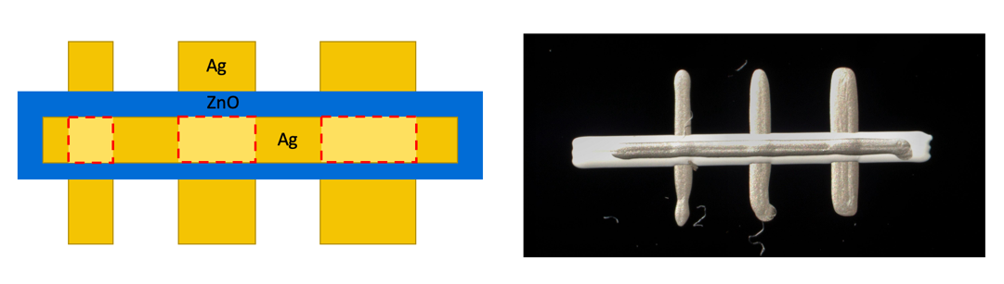
a)
b)
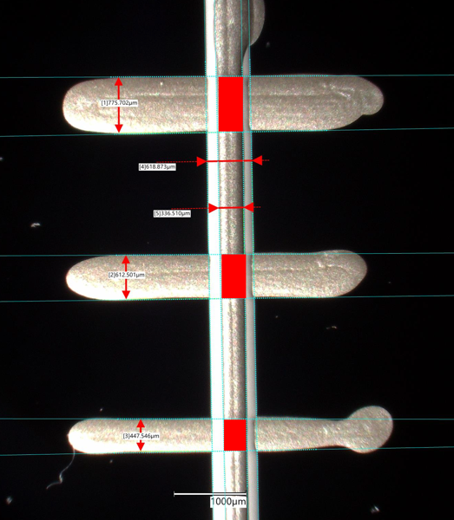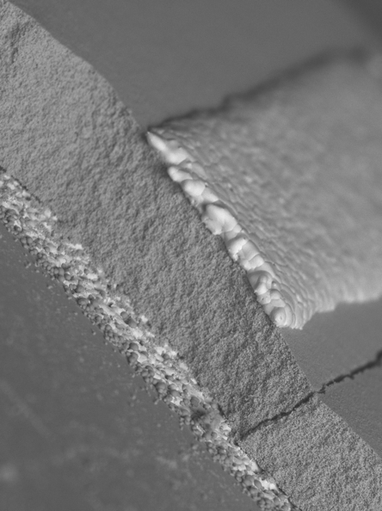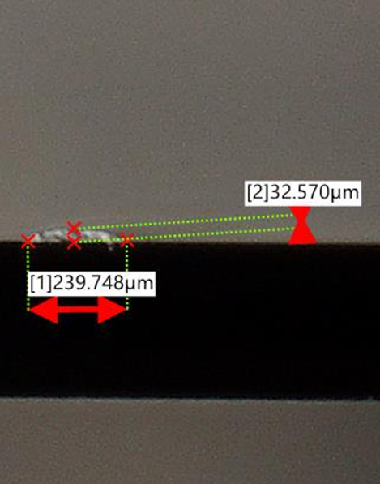
e)
d)
c)
Figure 3: a) Illustration of DIW printed layers, active layers outlined with red dotted lines. b) DIW printed device. c) Active area dimensions (highlighted in red). d) SEM image of Ag-ZnO-Ag layer thickness. Ag and ZnO is approximately 15µm and 50µm thick respectively. e) Smallest thickness obtained of ZnO.
- Results
Previous literature has achieved functioning RRAM devices with the semiconductor thickness of 50nm to 10µm via inkjet, screen, aerosol jet, and EHD printing. The thickest semiconducting layer in a RRAM device studied was 37µm (E. Gale, R. Mayne, A. Adamatzky, and B. de Lacy Costello, 2014). The smallest line thickness achieved by the ZnO formulation was 32.5µm as seen in Figure 3e. However, when printing over the silver electrodes, it is very hard to know what thickness is printing over the raised surfaces. Most of our devices had a thickness of about 50µm. The thickness of the top and bottom electrons was approximately 15µm. A cross section of the uncured ZnO device can be seen in Figure 3d.

Method 1 resulted in a lot of cracking of the ZnO layer, as well as poor adhesion of the silver top electrode to the ZnO, as seen in Figure 4a. The coefficient of thermal expansion of the silver electrodes is much higher than that of the ZnO. As the temperature rises, the silver is expanding much faster than the ZnO, so it is pulling the ZnO apart between those active areas. This leads to severe cracking resulting in a device with no performance. SEM images of Method 1 can be seen in Figure 4b.

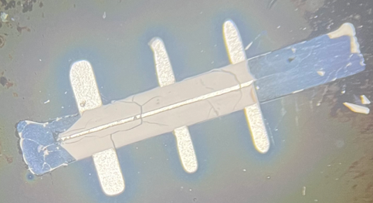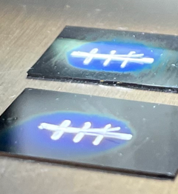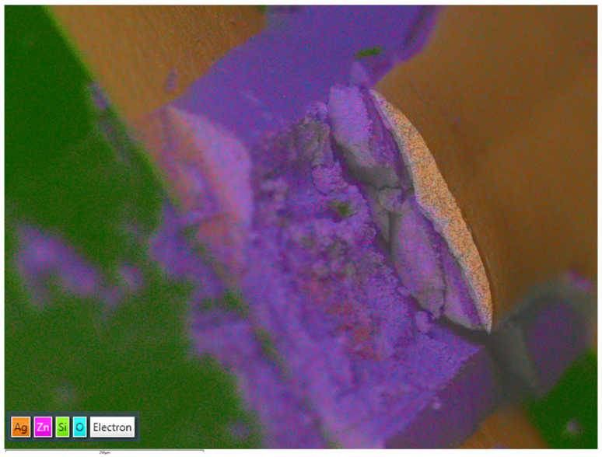
b)
a)
Figure 4: a) Cracking of ZnO and poor adhesion of top Ag electrode. b) SEM image of cross section of printed device showing cracking between electrodes using Method 1.

To solve the issue of cracking and poor adhesion between layers, the ramp rate of Method 2 was decreased and the silver and ZnO layers were dried together. By slowing down the sintering process we observed much less cracking within the layers; however, our devices were still not functional. After breaking up the devices for imaging, we revealed that the layer was still cracking off of the substrate and the bottom electrode as seen in Figure 5. However, the ZnO itself had resistance of about 5-6 MΩ and 2-3MΩ for the 900 degrees and 1000 degrees respectively.

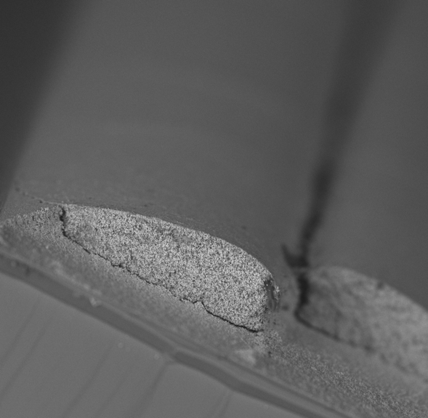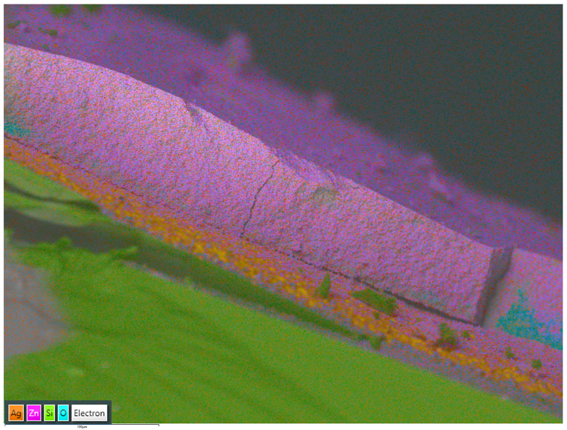
Figure 5: SEM images of ZnO layer cracking using Method 2.

Method 3 sintered at a lower temperature using the same ramp rate as Method 2 but for a longer amount of time to alleviate the difference in thermal expansion further. In this way most of the organic material could be baked off while still maintaining the conductive properties of the ZnO. As seen in Figure 8, we obtained good adhesion between layers with minimal cracking. Four devices were sintered using this method and only one device exhibited switching behavior. The resulting IV curve can be seen in Figure 9. The device forms a conductive bridge in the first switching cycle around 3.2V (V_{form}). It starts in a HRS, then switches to a LRS around 2.75V (V_{set}), then when reverse voltage is applied it stays in a LRS until the device resets around 2.25V (V_{reset}). The curve tracer did not have the capability to take measurements over time so these results should be taken with an appropriate amount of skepticism.

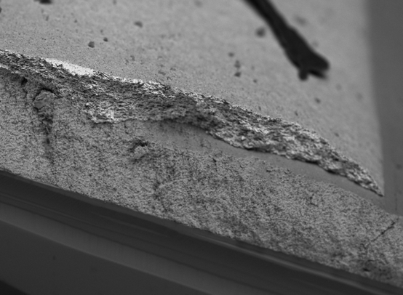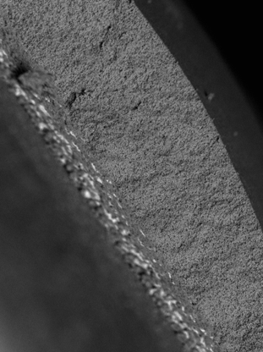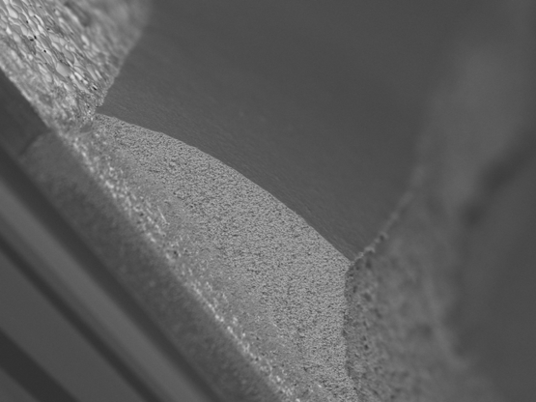
Figure 8: SEM images of ZnO layer with minimal cracking and good adhesion using Method 3.
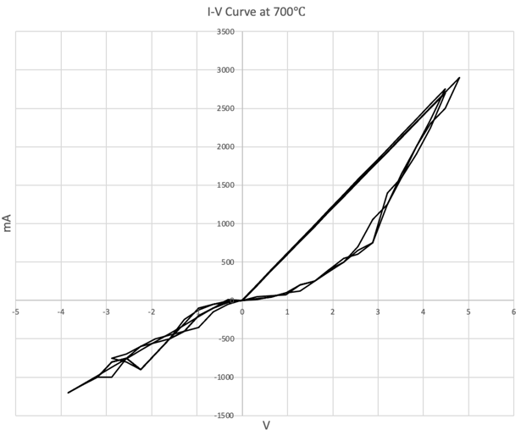
Figure 9: I-V curve of DIW printed RRAM device using Method 3.
- Discussion
The timeline of this project did not allow for further testing of this technique and these devices because the equipment is located at MSFC and I needed to return to the University lab in Wisconsin. More work is needed to verify the switching behavior of the DIW printed device above; this is in no way a confident, conclusive report of the results. I hope to return to MSFC in next spring or summer to validate these results in a more conclusive manor.

Future work would involve varying sintering temperatures and times at lower ramp rates to validate the work above. Receiving the appropriate curve tracer back from calibration would allow precise and formal testing on the printed devices. Potentially a thermogravimetric or KPFM analysis could be conducted to further characterize the materials and devices themselves. Laser sintering could also be explored as an alternative to furnace sintering. Different electrode materials could alleviate the cracking due to the difference in thermal expansion between materials. Finally, a smaller nozzle could be used to obtain a thinner semiconducting layer.
- Acknowledgements
This project would not be possible without generous funding from the Wisconsin Space Grant Consortium (WSGC) and National Space Grant College Fellowship Program.
References
Ali, S., Bae, J., Lee, C. H., Shin, S., & Kobayashi, N. P. (2017). Ultra-low power non-volatile resistive crossbar memory based on pull up resistors. Organic Electronics, 41, 73–78. doi:10.1016/j.orgel.2016.12.007
Arrabito, G., Aleeva, Y., Pezzilli, R., Ferrara, V., Medaglia, P. G., Pignataro, B., & Prestopino, G. (2020). Printing zno inks: From principles to devices. Crystals, 10(6), 449. doi:10.3390/cryst10060449
Bertolazzi, S., Bondavalli, P., Roche, S., San, T., Choi, S.-Y., Colombo, L., … Samorì, P. (2019). Nonvolatile memories based on graphene and related 2D materials. Advanced Materials, 31(10), 1806663. doi:10.1002/adma.201806663
Bessonov, A. A., Kirikova, M. N., Petukhov, D. I., Allen, M., Ryhänen, T., & Bailey, M. J. (2014). Layered memristive and memcapacitive switches for printable electronics. Nature Materials, 14(2), 199–204. doi:10.1038/nmat4135
Catenacci, M. J., Flowers, P. F., Cao, C., Andrews, J. B., Franklin, A. D., & Wiley, B. J. (2017). Fully printed memristors from Cu-SIO<inf>2</inf> core-shell nanowire composites. 2017 75th Annual Device Research Conference (DRC). doi:10.1109/drc.2017.7999482
Franco, M. A. M. (2016). Resistance Switching Memory Devices based on Zinc Oxide Nanoparticles on Paper Substrates (dissertation).
Gale, E., Mayne, R., Adamatzky, A., & de Lacy Costello, B. (2014). Drop-coated titanium dioxide memristors. Materials Chemistry and Physics, 143(2), 524–529. doi:10.1016/j.matchemphys.2013.09.013
Janotti, A., & Van de Walle, C. G. (2009). Fundamentals of zinc oxide as a semiconductor. Reports on Progress in Physics, 72(12), 126501. doi:10.1088/0034-4885/72/12/126501
Kong, Y. L., Tamargo, I. A., Kim, H., Johnson, B. N., Gupta, M. K., Koh, T.-W., … McAlpine, M. C. (2014). 3D printed quantum dot light-emitting diodes. Nano Letters, 14(12), 7017–7023. doi:10.1021/nl5033292
Muhammad, N. M., Duraisamy, N., Rahman, K., Dang, H. W., Jo, J., & Choi, K. H. (2013). Fabrication of printed memory device having zinc-oxide active nano-layer and investigation of resistive switching. Current Applied Physics, 13(1), 90–96. doi:10.1016/j.cap.2012.06.017
Nelo, M., Sloma, M., Kelloniemi, J., Puustinen, J., Saikkonen, T., Juuti, J., … Jantunen, H. (2013). Inkjet-printed memristor: Printing process development. Japanese Journal of Applied Physics, 52(5S1). doi:10.7567/jjap.52.05db21
Park, Y., Yun, I., Chung, W. G., Park, W., Lee, D. H., & Park, J. (2022). High‐resolution 3D printing for Electronics. Advanced Science, 9(8), 2104623. doi:10.1002/advs.202104623
Siebert, L., Wolff, N., Ababii, N., Terasa, M.-I., Lupan, O., Vahl, A., … Adelung, R. (2020). Facile fabrication of semiconducting oxide nanostructures by direct ink writing of readily available metal microparticles and their application as low power acetone gas sensors. Nano Energy, 70, 104420. doi:10.1016/j.nanoen.2019.104420
Simanjuntak, F. M., Panda, D., Wei, K.-H., & Tseng, T.-Y. (2016). Status and prospects of zno-based resistive switching memory devices. Nanoscale Research Letters, 11(1). doi:10.1186/s11671-016-1570-y
Torres Arango, M. A., Abidakun, O. A., Korakakis, D., & Sierros, K. A. (2017). Tuning the crystalline microstructure of al-doped zno using direct ink writing. Flexible and Printed Electronics, 2(3), 035006. doi:10.1088/2058-8585/aa8801
Tubío, C. R., Guitián, F., & Gil, A. (2016). Fabrication of zno periodic structures by 3D printing. Journal of the European Ceramic Society, 36(14), 3409–3415. doi:10.1016/j.jeurceramsoc.2016.05.025
Xu, S., & Wu, W. (2020). Ink‐based additive nanomanufacturing of Functional Materials for human‐integrated Smart Wearables. Advanced Intelligent Systems, 2(10), 2000117. doi:10.1002/aisy.202000117
Zahoor, F., Azni Zulkifli, T. Z., & Khanday, F. A. (2020). Resistive random access memory (RRAM): An overview of materials, switching mechanism, performance, multilevel cell (MLC) storage, modeling, and applications. Nanoscale Research Letters, 15(1). doi:10.1186/s11671-020-03299-9

