Using sUAS Multispectral Imagery to Determine the Effect of Prescribed Burns on C3 and C4 Plant Communities in a Reclaimed Wisconsin Prairie

Ava Beyers¹, Trent Ediger², Katherine McClain², Haley Siculan³

Geosciences & Environmental Sciences, Carthage College¹
Geosciences, Lawrence University²
Environmental Sciences, Lawrence University³

Abstract
We examine the effect of prescribed burns on C3 and C4 plant communities in a reclaimed Wisconsin prairie ecosystem. Our research builds off previous work to discriminate between C3 and C4 plants and further determine the effects of prescribed burns on the area using sUAS imagery. We find that the area most recently burned (2023) is more vegetated overall with warmer and drier soil, and that C4 plants are more common than C3 plants throughout the entire study site. This aligns with previous research which shows that C4 plants thrive in warmer and drier environments cultivated by burning. Our findings illuminate ecosystem dynamics after fire; this will become increasingly important as we see a rise in wildfires and droughts due to climate change. As these climate effects become more prevalent, it is imperative to understand how ecosystems respond so that prairie managers can more effectively cultivate biodiversity and abundant plant communities.

Introduction
The Fox Valley area has changed rapidly since European colonization. North of Lake Winnebago, the area continues to evolve due to industrialization, suburbanization, and climate change. The main threat to the area is climate change, which directly causes warmer and drier conditions and produces an increased wildfire risk, further accentuating these changes (Fu et al., 2021). These compounded effects of a warming climate might promote the less desirable C4 plants. Our analysis of how fire affects the plant makeup of the prairie at Heckrodt Wetland Reserve will hopefully be useful for stewards of natural Wisconsin spaces similar to the study’s reclaimed prairie.

Study Site. Heckrodt Wetland Reserve is a 37-hectare urban nature preserve in Menasha, Wisconsin which was originally part of an extensive wetland system that ringed Lake Winnebago. The ecological makeup of the area is complex, including both northern mixed forest and southern broadleaf trees as well as wetlands. The first humans in the area were the Menominee, and the area has also been inhabited by the Ho-Chunk, Oceti Sakowin, Miami, and Meskwaki Indigenous nations. The area of interest is a 1.8-hectare former alum sludge waste site that was capped with topsoil and seeded with mixed prairie plants in 2006 (Fig. 1). Although this area may have originally been a wetland, it was converted into a prairie as part of a larger restoration effort. Management practice includes prescribed burns and annually collecting and redistributing seeds. Our focus is on the prescribed burns. The prairie is divided into three zones, which have been treated similarly by the managers, differing only in their burn treatment. Zone 1 was burned in 2016 and 2023, Zone 2 was burned in 2017 and 2021, and Zone 3 has never been burned (Fig. 1). Zones 1 and 2 are mixed areas of grasses, flowering plants, and bare soil (Neuman, personal communication). Zone 3 is a woodland edge habitat containing trees (Populus sp.) and woody plants (Rhamnus cathartica). Tree cover prevented usable aerial imagery of the zone; thus, it was excluded from the study.
Project Goals. Our interest lies in determining the effects of prescribed burns and by extension natural fires on a prairie ecosystem. Specifically, we wanted to investigate whether the burned prairie area created an environment more conducive to C3 broadleaf and flowering plants or C4 grasses. Heckrodt Wetland Reserve’s goals for the reclaimed prairie include greater flower biodiversity, increased flowering plant populations, and sustainable management practices. However, previous work suggests that burning creates warmer and drier soil conditions, which are preferred by C4 plants (Ewing et al., 1988). Heckrodt managers have noticed the decline of C3 plants while the C4 plants, which include Sorghastrum nutans and Schizachyrium scoparium, overtake them. Information on why this decline is occurring is valuable to the caretakers so they can increase biodiversity, support pollinators, and support the prairie as it evolves alongside the local climate. In this study, we use both aerial imagery via sUAS and in-situ botanical survey techniques to determine whether prescribed burning has created an environment conducive to C4 plants at Heckrodt Wetland Reserve. The results of this study will be provided to Heckrodt Wetland Reserve and used to create an updated management plan for the prairie.

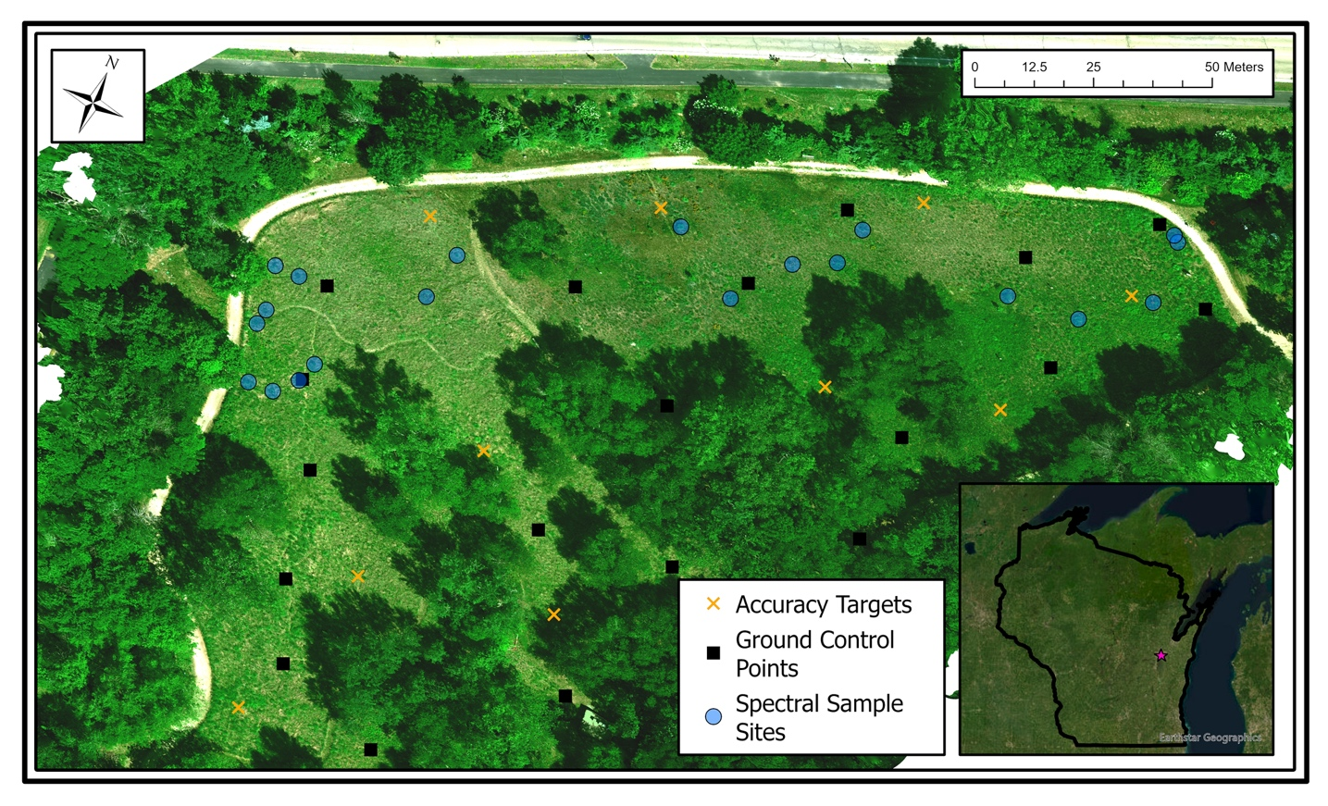

Figure 1. True color orthomosaic from July 3, 2023, of Heckrodt Wetland Reserve’s reclaimed prairie with ground control points (GCPs), accuracy target locations, and spectral sample sites. Inset shows study site location within Wisconsin marked with a star.

C3 and C4 Plants. The plants in Zones 1 and 2 can be categorized by their photosynthetic pathways. C3 plants use a three-carbon molecule to photosynthesize, while C4 plants use a four-carbon molecule to photosynthesize. C4 plants evolved from C3 plants to adapt to warmer and drier climates, while plants that utilize C3 photosynthesis thrive in moderate, temperate climates. In northeast Wisconsin, C3 plants tend to be flowering and broadleaf, while C4 tend to be grasses (Fig. 2). No C3 grasses or C4 broadleaf plants have been observed at Heckrodt. We have observed what appears to be a dominance of C3 plants in Zone 3, but unfortunately cannot quantify it due to the canopy coverage.

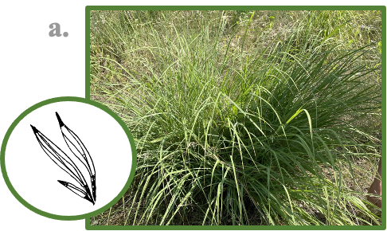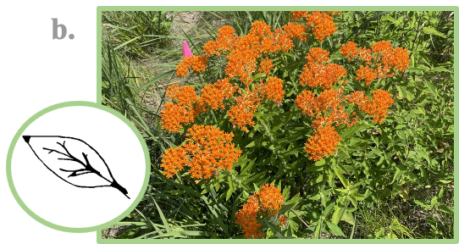

Figure 2. Figure 2a shows Sorghastrum nutans, a C4 plant that the stewards of Heckrodt have observed taking over the prairie. Figure 2b shows Asclepias tuberosa, a common C3 plant at Heckrodt that supports the monarch butterfly population. Both plants are healthy, native species originally planted by management.

Materials and Methods
Field Methods. To determine the impact of prescribed burns on C4 and C3 plants, we took aerial imagery of the prairie with a DJI Matrice 200 V2 drone with a MicaSense Altum 8mm multispectral camera (Table 1). Equipment used in the field also included an Emlid Reach RS2 base and rover GNSS to precisely locate 20 ground control points (GCPs) and 10 accuracy targets in the NAD83 coordinate reference system (Fig. 1). Six flights were conducted between June 22 and July 17, with the hope of distinguishing temporal trends (Table 2). One flight was not used due to uneven lighting conditions resulting from partly cloudy weather. We anticipated the spectral response of C3 and C4 plants would peak at some point in the summer, at which time the spectral signatures would be most distinct (Liu et al., 2015). We flew multiple flights to ensure we would capture the peak reflectance and get the most accurate classification. We designated 20 spectral sample sites (Fig. 1), ten C3 and ten C4, to be used in spectral signature analysis. These ground truth sites were known areas of either a C3 or C4 plant with a 20 cm radius and were surveyed with the GNSS.

In-situ soil data were collected using a Vernier meter paired with soil moisture and temperature sensors, inserted two inches into the topsoil at the GCP locations. Soil surveys took place before each flight throughout the summer.

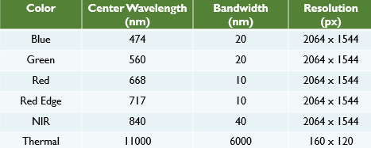
Table 1. Specifications for the Micasense Altum 8mm multispectral bands.

Lab Methods. GCP locations were utilized in Agisoft Metashape to stitch the drone imagery into an orthomosaic (e.g. Fig. 1). Ten accuracy targets were used to visually assess the orthomosaic quality by comparing the average distance between each target’s location in the model to the location we measured using our GNSS base and rover (see “orthomosaic fit” in Table 2).

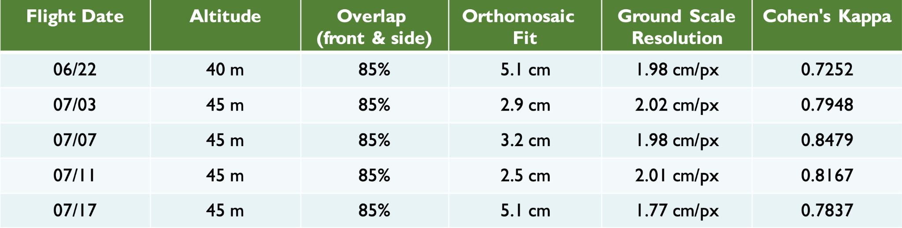

Table 2. Flight parameters and fit. Orthomosaic fit is a measure of how much a given pixel may be different between the model and its location in real space. Accuracy targets were used to visually measure this difference. Cohen’s kappa is the result of an accuracy assessment of the classification (Cohen 1960). A kappa (k) value greater than .61 is considered substantial agreement between the classification and the actual ground cover (-1 < k <1).

Satellite-based multispectral imagery has been used to successfully discriminate between C3 and C4 plant communities (Crabbe et al., 2019 and Liu et al., 2015). Our methodology adopts a similar approach with sUAS-acquired aerial imagery. After the orthomosaic was created it was imported into Esri ArcGIS Pro for analysis. ArcGIS Pro was used to segment and classify the orthomosaics into C3, C4, and Dead/Bare Soil land cover classes using a random trees classifier (Bhatt et al., 2023). For our classification we used green, red-edge, and near infrared (NIR) reflectance to distinguish the three types of land cover most clearly. The spectral signatures of C3 and C4 plants exhibited the highest contrast in the red-edge and near infrared wavelengths, whereas they were nearly indistinguishable in the visible range (Fig. 3). Green reflectance was used in tandem to assist the classifier in accurately distinguishing dead grass and bare soil from living plants.

Figure 3. Spectral signatures of C3 and C4 plants obtained from spectral sample sites (Fig. 1). Note: the plotting positions are offset slightly to facilitate comparison.

Accuracy assessment. We assessed the accuracy of the classification with 130 random points by comparing their classified value to the ground truth value (Fig. 5). We ran a confusion matrix on the accuracy assessment points to calculate Cohen’s kappa, which compares the agreement between two datasets (classified and ground truth) to determine accuracy. A value above 0.61 is considered substantial agreement between the two datasets, and above 0.81 is near perfect agreement. All kappa values are between 0.72 and 0.85 suggesting a strong agreement between the automated classification and the real-world land cover (Table 2).

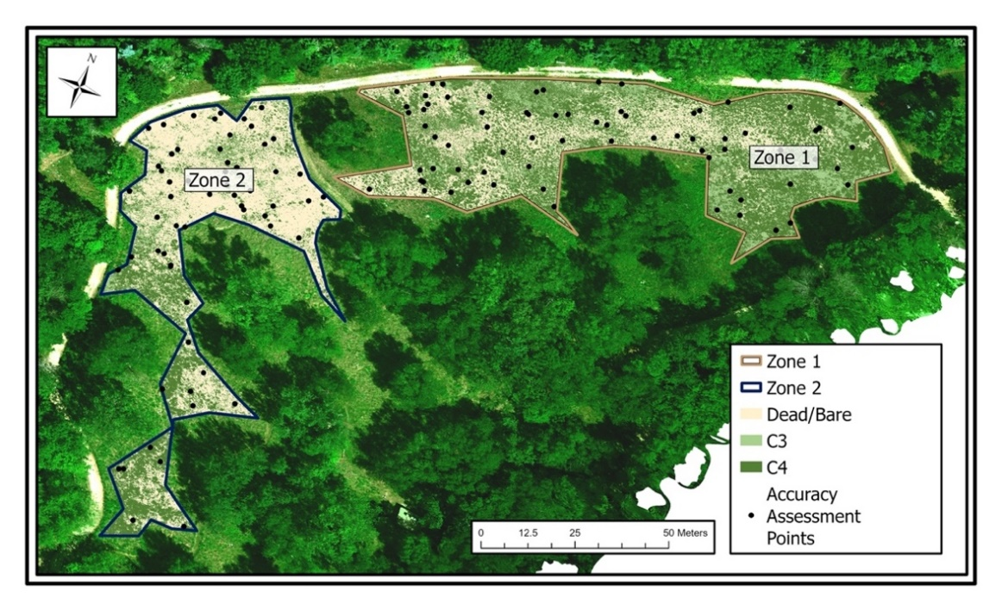
Figure 5. Classification of Dead Grass/Bare Soil, C3, and C4 vegetation with accuracy assessment points overlaid the true color orthomosaic for July 3, 2023.

Key Results
C3 and C4 Plant Communities. Findings from the summer flights show that Zone 1 consistently has a higher proportion of living plants than Zone 2 (Fig. 6). On average, Zone 1 is 84% vegetated while Zone 2 is only 63% vegetated (p < 0.001). Our field observations also suggest that Zone 2 contains far more dead grass than Zone 1, which almost exclusively contains plant coverage or bare soil, but no dead vegetation. Apart from Zone 2 during our June 22 flight, C4 coverage is consistently higher than C3 in both zones. On average, C4 takes up 66% of the live vegetation in Zone 1, compared to 62% in Zone 2, though the difference between zone averages is not statistically significant (p > 0.25). This may be affected by the outlier, Zone 2 on June 22, our only instance where C3 was greater than C4.
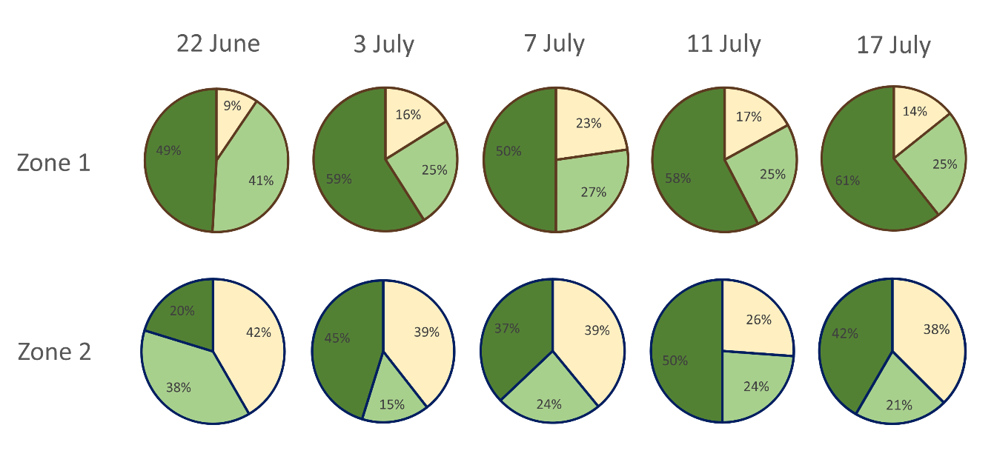
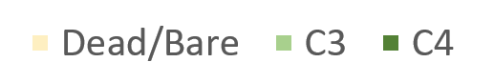
Figure 6. Percent coverage of C3 plants, C4 plants, and Dead/Bare in zones 1 and 2 by flight date.

Soil Conditions. Zone 1 had a consistently warmer thermal signature than Zone 2. This can clearly be seen in both the thermal imagery (Fig. 7) as well as the in-situ measurements (Fig. 8). Thermal imagery depicts heat emitted from the surface. Zone 1 emits more heat, likely because Zone 1 contains more bare soil which absorbs more sunlight and therefore heats up more than vegetation (living or dead). This is supported by our field observations which suggest that Zone 2 contains little bare soil but has a large proportion of dead grass. Not only do direct soil temperature measurements show that Zone 1 is significantly warmer (p < 0.001) but paired moisture readings also show it is drier (p < 0.08) than Zone 2 (Fig. 8) throughout the entire summer.

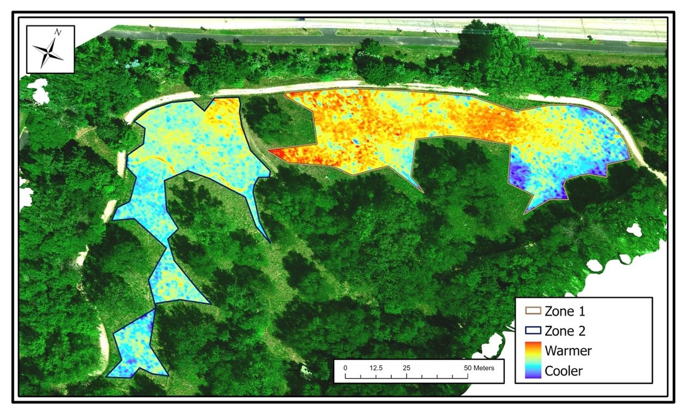

Figure 7. Thermal imagery overlaid on true color orthomosaic from July 7 flight. Thermal imagery is a measure of heat emitted from the surface.

Figure 8. Soil temperature and moisture taken at GCP sites throughout the summer. Each point is an average of all the sites (n) in that zone. In Zone 1, n = 10 and in Zone 2, n = 6. Zone 1 (2023 burn) is warmer and drier than Zone 2.

Temporal Trends. C3 and C4 plants exhibit different spectral responses to their morphology, and as a result their near infrared and red-edge reflectance develop differently throughout the growing season. C3 plants reflect less in these wavelengths in the spring, but then reflect more than C4 plants in the summer, hitting a midsummer peak in distinguishability before senescing in autumn (Liu et al. 2015). In our study period, C3 plants consistently had higher red-edge and NIR reflectance than C4 with little variation (Fig 9a). Additionally, there were no significant temporal trends in the reflectance values of C3 and C4 plants in these wavelengths. We expect that had we taken data earlier in the growing season (spring) or later (fall) we would see the reversal in reflectance values reported in the literature (e.g. Liu et al. 2015).

The relative abundances of C3 and C4 plants showed no significant changes throughout the summer. The coverage of Dead/Bare also stayed constant, demonstrating that the area did not become more vegetated over the short period in which we observed it (Fig. 6). Soil temperature and moisture showed temporal trends likely controlled by ambient temperature and rainfall; the increase in moisture between July 11 and July 17 corresponded with rainfall in the area (Fig. 8).

Figure 9. Red-edge (a) and near infrared (NIR) (b) reflectance of C3 and C4 plants across time.

Discussion
Prescribed fire is a natural and healthy part of prairie ecosystems. The managers of Heckrodt Wetland Reserve use fire to maintain flowering perennials and pollinator plant populations, and suppress growth of woody vegetation and reduce wildfire risk. Our work demonstrates that the 2023 burn was successful in clearing dead vegetation and stimulating new growth, as the combined concentration of C3 and C4 plants was higher in the more recently burned Zone 1 (Fig. 6). We also observe that Zone 1 is significantly warmer and drier than Zone 2 (Fig. 8). The warmer signature is likely due to sunlight heating and drying the bare soil exposed by the fire. We propose that the dead grasses in Zone 2 shade the area, keep it cooler and moister, while simultaneously inhibiting new growth.
When management originally created the prairie in 2006, they seeded it with twice as many C3 plants as C4 plants (Neuman, personal communication). C4 plants became established in the prairie despite their originally diminished proportion, suggesting that the environmental conditions may be conducive to C4 plants. A variety of factors could be responsible for the proliferation of C4 plants, including global/local climate, soil conditions, or the prescribed burns. Another confounding factor may be herbivory of white-tailed deer at the reserve. However, the 4% difference between C4 relative abundance in Zone 1 (66%) and Zone 2 (62%) aligns with previous research that elucidates a positive correlation between prescribed burns and C4 growth (Ewing et al., 1988). This smaller than expected difference could be attributable to the short time interval between the zoned burns. Both zones were burned within the last three years, which may not have allowed Zone 2’s C3 plant community sufficient time to establish a higher concentration compared to Zone 1.

Conclusion
Our research suggests that the current management practices for spring prescribed burns in the reclaimed Wisconsin prairie are conducive to an environment dominated by C4 warm-season grasses. By clearing out old growth, burns expose bare soil and create warmer and drier soil conditions preferred by C4 plants. Repeated seeding has likely slowed the decline of flowering C3 plants, but management has nonetheless noticed their presence decreasing. Our findings also support this observation. Managers might consider reseeding both zones with fewer C4 plants to maintain the preferred ratio of C3 to C4 plants. Less frequent burns may also create soil conditions more suited to C3 plants, thus supporting pollinator habitats; however, reducing the burn frequency will also increase the concentration of dead grasses and could allow woody plants to establish themselves. Managers at nature reserves like Heckrodt should consider utilizing sUAS research in place of traditional in situ botanical surveys because drone surveys can be more efficient and less invasive.

As climate change increases the frequency of droughts and heat waves, wildfires will become more common (Abatzoglou et al., 2016). Because of this, it is increasingly important that we bolster our understanding of fire’s effects, both wild and prescribed, on prairie ecosystems. Knowledge of these effects will help caretakers better manage their land and help us better understand the consequences of more frequent wildfires.

Acknowledgements
We would like to thank Professor Jeffrey Clark of Lawrence University for his guidance throughout this research; the Wisconsin Space Grant Consortium for this wonderful opportunity; and the Heckrodt Wetland Reserve staff, especially Emma Neuman, for providing us with access to the study site and records of its stewardship. A final thank you to our colleague, Rodney Watkins (1964-2023).

References
Abatzoglou, J. and A. Park Williams (2016). “Impact of anthropogenic climate change on wildfire across western US forests.” Proceedings of the National Academy of Sciences of the United States of America vol. 113,42. 11770-11775. doi:10.1073/pnas.1607171113.
Bhatt, P. & Maclean, A. (2023). Comparison of high-resolution NAIP and unmanned aerial vehicle (UAV) imagery for natural vegetation communities classification using machine learning approaches. GIScience & Remote Sensing. 60. 10.1080/15481603.2023.2177448.
Crabbe, R., Lamb, D., & Edwards, C. (2019). Discriminating between C3, C4, and mixed C3/C4 pasture grasses of a grazed landscape using multi-temporal sentinel-1a data. Remote Sensing, 11(3). doi.org/10.3390/rs11030253.
Ewing, A. L., & Engle, D. M. (1988). Effects of late summer fire on tallgrass prairie microclimate and community composition. American Midland Naturalist, 120(2), 211–223. doi.org/10.2307/2426020
Fu, R., et al. (2021). Tackling Challenges of a Drier, Hotter, More Fire-Prone Future. Eos.
Iglesias, V., Balch, J., Travis, W. (2022). U.S. fires became larger, more frequent, and more widespread in the 2000s. Science Advances, vol. 8, no. 11). 10.1126/sciadv.abc0020
Liu, X., Bo, Y., Zhang, J., & He, Y. (2015). Classification of C3 and C4 vegetation types using Modis and ETM+ blended high spatio-temporal resolution data. Remote Sensing, 7(11). doi.org/10.3390/rs71115244
Steuter, A. (1987). “C₃/ C₄ Production Shift on Seasonal Burns: Northern Mixed Prairie.” Journal of Range Management, vol. 40, no. 1, pp. 27–31. JSTOR, https://doi.org/10.2307/3899356.

